**Encouraging Social Interactions,**

**Making Friends, & Healthy Relationship Building for Young Children**

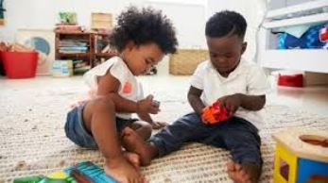

How Can Parents Assist Their Young Children in Developing Appropriate Social Interactions, Make Friendships, and Build Healthy Relationships?

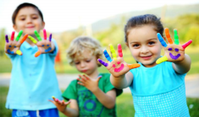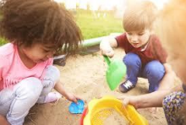

**Relationship Building & Young Children**

★ **For children, making friends is a vital part of growing up and an essential part of their social and emotional development.**

★ **As children build relationships, they build on skills that help them maintain friendships now and in the future. Skills like sharing, taking turns, cooperating, listening to others, managing disappointments and seeing others point of view.**

★ **Attributes such as social competence, self-esteem, and self-confidence have all been found to be positively**

**correlated to having friends.**

**What is Relationship Building?** 

● The process of establishing emotional connections with others ○ Starts at birth & are based on trust and intimacy

● Relationships help children discover:

○ Who they are

○ How to understand others

● Relationships that model helping, understanding, and enjoyment help young children: ○ Approach the world with openness and enthusiasm

○ Grow to be responsive and caring people

● Forming Positive & Healthy Relationships Depends on the Ability to: ○ Show feelings appropriately

○ Recognize the feelings of others

**(Taken from: Zero To Three- Support Your Child Relationship Building Skills)**

**What is Relationship Building?** 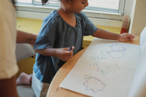

● Teach young children acceptable ways to vent anger, such as: ○ Drawing an angry picture

○ Running in the yard

○ Tossing a pillow on the floor

● Label your own feelings:

○ “I am happy because you helped me clean up.”

○ “I am sad that Grandma had to fly home.”

● It is important for children to know that you have feelings too and that there are ways to cope with them in order to feel better.

**(Taken from: Zero To Three- Support Your Child Relationship Building Skills)**

**7 Important Social Skills**

Social skills are set of skills that need ongoing refinement as your kids get older. These skills can be learned and strengthened with effort and practice.

1. Sharing 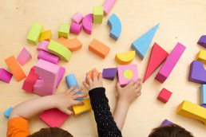

2. Cooperating

3. Listening

4. Following Directions

5. Respecting Personal Space

6. Making Eye contact

7. Using Manners

Social skills have a wide range of benefits. They are linked to greater success in school and better relationships with peers. You can help your child learn these skills by modeling them. (Verywell Family site)

**Social Skills Our Students Practice in School**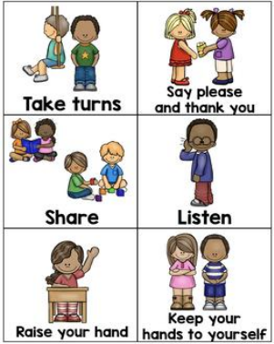

**Strategies to help children build relationships:**

● Make Time: Since parents dictate the schedule outside of school, it’s important to set aside time for your children to spend time with friends. For younger children reach out to the parents of your children’s classmates so you can proactively schedule play dates.

● Show Appreciation: Teach children to appreciate others by making it a regular habit to communicate to loved ones how important they are to you.

● Work It Out: Instead of stepping in to resolve conflicts for your children, give them the tools to work it out on their own.

**Strategies to help children build relationships:**

● **Share with Others:** Teach children to enjoy sharing by regularly sharing your favorite things with them such as food, trinkets, and books, and discuss how it feels for both of you.

**● Weed Out Negativity:** Negative relationships can be taxing to your family’s emotional and physical health. Talk with kids about the principles of being a good friend and the importance of respect in a friendship.

**● Model Empathy and Cooperation:** Empathy involves compassion and understanding the feelings of others. However, it isn't enough just to have an empathetic thought -- you have to act upon it.

**Trouble with Sharing**

Difficulties with sharing is a common behavior for toddlers and preschool- aged children. What can parents do to encourage their little ones to share? Here are 6 easy activities that can assist young children learn how to share.

● Paint a picture/ make something with playdoh: Teach your child to share by coloring or painting something together. Grab a large white paper and your painting supplies, and decide on a subject together. Share the art tools that you are using. Ask them to pass you the paintbrush and to share a color of paint. You can do the same using Playdoh. Be sure to share your tools with them, too!

**●** Play the magic ball: This is a hot potato- style game that addresses sharing. As you sing the words to the song, kids pass the ball from one to the next. In this game, no one wants to hoard the ball for fear of being “it.” If you don’t have a ball, you can play the game around the kitchen table using an apple of orange. You can also make up the words to your own song as you’re passing around the object.

**Trouble with Sharing**

**●** Sing a sharing song: Make up a simple sharing song with your child such asby playfully repeating the phrase “Sharing is Caring,” or adapting the words to a favorite lullaby or song from a favorite movie. This gives you quality time with your child while stressing the importance of sharing in an enjoyable way.

● Share your attention: Your children can often have a hard time sharing attention. To help your child get better at sharing their attention, have your child and a sibling sit next to you or on your lap at the same time and interact with each child separately. Play a game like “pat-a-cake,” with your child and then let him/her observe while you play tic-tac-toe with your 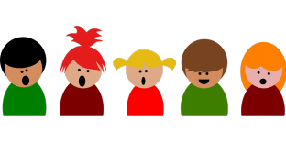other child. Simply doing this helps children learn to share your attention with others.

**Trouble with Sharing**

**● Pass the crackers:** Give your child a handful of crackers. Ask them to give one to each person in the room. “Give one to mommy, please. Can you give one to your sister, please?” This can normalize sharing for the child and help them understand that sharing is a regular part of life.

**● Show them how it’s done:** Use subtle activities to demonstrate how to share. Whenever you share something with your child, point out that you are sharing. You might say something like, “I’ll share my apple with you. Here are some slices for you, and here are some slices for me.” When you let a neighbor borrow a tool, mention to your child that you are sharing the hedge clippers. In your regular play times, focus on when your child shares and provide lots of reinforcement when he/she shares something with you or others. This is especially important when you’re first teaching this skill. Don’t force your child to share, but praise them when they do. Children love it when you act excited when they do something positive- so when your child shares, be very enthusiastic about how great it is.

**Other Tips To Teach and Encourage Sharing:**

**● Set Limits Up Front:** When children are learning to take turns, it can be hard to know when it is time to give a favorite toy to their friend or sibling. Something visual, like a timer, will let children know exactly when it is time for them to give up a certain toy.

**● Correct Their Behavior:** If a situation occurs where a child reacts negatively to another child playing with a toy they wanted, explain that they can have a turn next. Children learn when a lot of adult encouragement is provided. Preschool age is when children are learning how to share and correcting their actions in the moment will help them learn.

**● Model and Point Out Good Behavior:** Although it is important to talk about taking turns and sharing, seeing it will help also. For example, point out how nice it was that Dad shared his water with Mom. “Thank for sharing, Dad!” Even pointing out when an older sibling takes turns or shares will help encourage children.

**● Talk About Sharing Toys With Friends:** Before a playdate, talk about why it is important to share with their friend. Let them know that it’s okay for their friend to play with their toys for a bit and when they go to their friend’s house their friend will share toys too. Talk about how it would feel if they went to a friend’s house and wasn’t allowed to play with any toys. If your child has an absolute favorite toy that they do not want to share, put that toy away before the playdate begins.

**Books on Being a Friend** 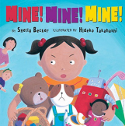

● Best Friends by Charlotte Labaronne

● Can you Be a Friend? By Nita Everly

● Fox Makes Friends by Adam Relf

● How do Dinosaurs Play with Their Friends by Jane Yolen & Mark Teague ● I’m a Good Friend! by David Parker

● I Can Share by Karen Katz

● I Can Cooperate! by David Parker 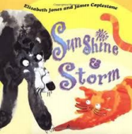

● Making Friends by Fred Rogers

● Mine! Mine! Mine! By Shelly Becker

● My Friend Bear by Jez Alborough

● Sharing How Kindness Grows by Fran Shaw

● Sunshine and Storm by Elisabeth Jones

● Talk and Work it Out by Cheri Meiners

● Be Kind by Pat Zietlow Miller

Childhood 101

**The link above will take you to a list with books that address topics such as making friends, empathy, teamwork and cooperation, anti- bullying, sportsmanship skills, helping others, etc.**

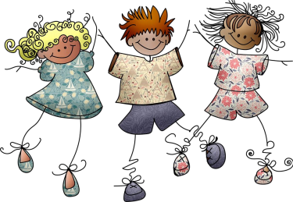

**Additional Resources**

Parent Science

Child Mind Institute 

Teaching Young Children Magazine

Young Children Journal

Questions or Comments

**Contact Information:**

**PIRT Team:**

**School 7 & Providers:**

**Solange Gialloreto**

solagialloreto@paps.net

**Jennifer Lenci**

jennlenci@paps.net

**Ignacio Cruz, ECC:**

**Kimberly Iuliano**

kimbiuliano@paps.net

**Antonette Mantle**

antomantle@paps.net

**Hmieleski ECC:**

**Virginia Kellon**

virgkellon@paps.net **Michelle Loconte (CPIS)** michloconte@paps.net

