**An Introduction to Teaching**

**Strategies Gold**

Presented by:

Master Teachers

January 14th, 2021



**Teaching Strategies Gold** Your Child’s Preschool Assessment System

**AGENDA:**

**● What is TSG?**

**● We will introduce objectives and dimensions used to assess your child's progress throughout the year.**

**● You will learn what a “color band” is, and what that means for your child’s development.**

What is Teaching Strategies Gold?

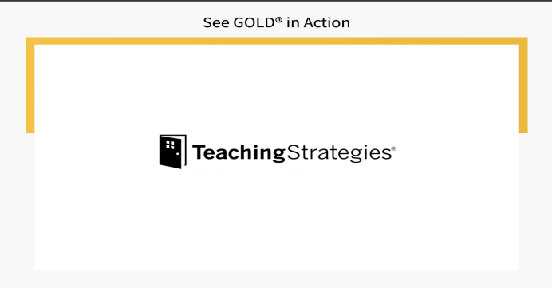See Gold in Action

**OBJECTIVES AND DIMENSIONS**

Dual Language classrooms will also use these objectives in addition to the ones we have reviewed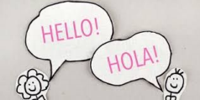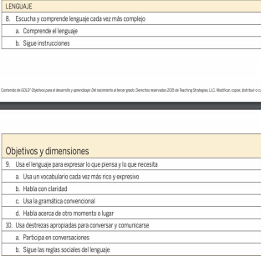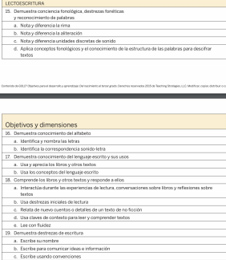

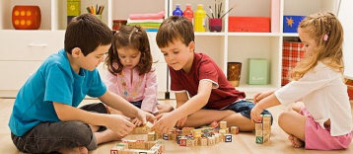

**These are the objectives we will assess to see how your child is developing socially and emotionally through observation. See above.**

**Right now we will look at C.- Interacts with Peers …**

The teacher observes and documents your child’s interactions during the school day. He or she chooses the appropriate dimension and will fill in the circle that is aligned with his or her observation.

**What is a color band and what does it** 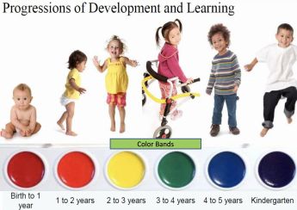

**mean?**

Our assessment

system is geared for

children from

stages birth to 3rd

grade.

**Understand Each Child’s Needs Based on Developmentally Appropriate Milestones**

The assessment model used in *GOLD*® follows widely held expectations for children birth through third grade and enables a whole-child approach to assessment. Color-coded progressions guide teachers toward selecting and adapting activities that support each child’s development and learning. Meaningful reports inform classroom practices and individualized instruction.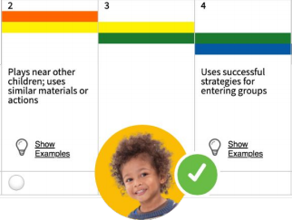

**How you can help support your child at home**

Keep a copy of these objectives and dimensions handy to help scaffold your

child to the next level

● Engage in back and forth conversations with your child ● Incorporate at least 15 minutes of movement into your day ● READ or listen to a story everyday with your child! ● Use everyday experiences to reinforce math skills, language development, and literacy

● Encourage your child to use various writing tools to practice fine motor skills

● Allow for your child to engage in imaginative PLAY!!!!

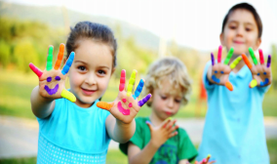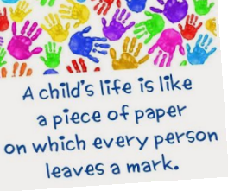Additional Resources for Families