Spring
Garden
Fine Motor Skills

Gross Motor Skills

Literacy

*Tear paper and make pretend rain for the flowers
*Make a rain drop bottle by putting rocks in an empty water bottle
*Flap your arms like a butterfly

*Pretend to be a frog and jump
*Practice putting on short sleeve shirts
*Help put winter clothes away and spring clothes out
Self Help

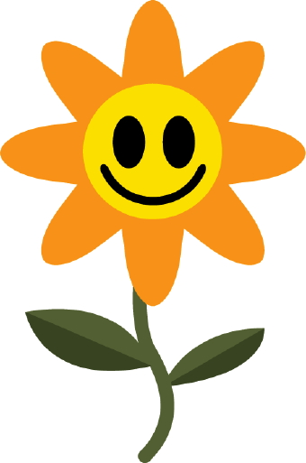
Circular Web for Creative Curriculum
Ideas for Learning at Home Using Every Day Items

Language

Math

*Count items that you see in the house

*Match socks and pairs of shoes

*Watch Mouse’s First Spring on YouTube

*Make a letter F for flower and practice the f sound
*Label Spring items that you see outside-grass, birds, flowers, sun, clouds, rain
*Play a fun game following directions to find hidden items

Learning is ongoing. We will be updating with more ways to incorporate learning into the children’s every day routines.

This web shows what the children will be learning about in the classroom and activities you can do at home to work on those skills.

